Sam Caldwell
Rohith Prakash

Lab 5 Report

OBJECTIVES

The goals of Lab 5 were to interface a SD card using our OS, designing and implementing a file system, and extending our shell to support file/disk IO and input redirecton, testing accuracy and performance along the way. An important part of the lab was layering the different interfaces for the card: serial, eDisk.c, eFile.c, and the shell/OS. Abstract hardware interfaces are a necessary feature for platform-independence.

SOFTWARE DESIGN
int eFile_Init(void) {
// initialize file system
int i;
volatile unsigned long delay;
if(_sysInit)
return 1;
eDisk_Init(DRIVE);
eDisk_ReadBlock(_blockBuff, DIRECTORY);
memcpy(_eFile_List, _blockBuff, sizeof(eFile_File) * MAX_FILES);
//count files
num_files = 0;
for(i = 1; i < MAX_FILES; i++)
if(_eFile_List[i].name[0])
num_files++;
_wOpen = _rOpen = 0;
_sysInit = 1;
// profiling code : set PB0 low when reading, high otherwise
SYSCTL_RCGC2_R |= SYSCTL_RCGC2_GPIOB;
delay = SYSCTL_RCGC2_R;
GPIO_PORTB_DIR_R |= 0x01; // output
GPIO_PORTB_DEN_R |= 0x01; // digital mode
GPIO_PORTB_DATA_R |= 0x01; // initialize high
return 0;
}

int eFile_Format(void)
{
eFile_WClose();
eFile_RClose();
// erase disk, add format
memset(_eFile_List, 0, sizeof(eFile_File) * MAX_FILES);
// create free space manager entry in the directory
strcpy(_freeList->name, "spc_mgr");
_freeList->firstBlock = 1;
_freeList->lastBlock = BLOCKS - 1;
_freeList->size = 0;
// write the space manager to the first entry in the directory
_eFile_ClearBlockBuff();
memcpy(_blockBuff, _eFile_List, sizeof(eFile_File) * MAX_FILES);
eDisk_WriteBlock(_blockBuff, DIRECTORY);
_eFile_MakeFreeList();
num_files = 0;
return 0;
}

int eFile_Create(const char name[FILE_NAME_SIZE]) {
// create new file, make it empty
int i;
if(_freeList->firstBlock == 0 || _eFile_Find(name))
return 1;

for(i = 1; i < MAX_FILES; i++)
{
if(_eFile_List[i].firstBlock == 0) //free space in directory
{
eFile_File* file = &_eFile_List[i];
char new_name[FILE_NAME_SIZE];
memcpy(new_name, name, FILE_NAME_SIZE);
new_name[FILE_NAME_SIZE - 1] = 0;
strcpy(file->name, new_name); // write file name
file->firstBlock = file->lastBlock = _freeList->firstBlock; // first block is first available block
_eFile_ClearBlockBuff();
eDisk_ReadBlock(_blockBuff, _freeList->firstBlock);
_freeList->firstBlock = (_blockBuff[0] | (_blockBuff[1] << 8)); //update freeList
_eFile_ClearBlockBuff();
memset(_blockBuff, 0, sizeof(_blockBuff[0]) * 2); // first 2 bytes are a null ptr
_blockBuff[WRITE_INDEX] = WRITE_INDEX + 2; // start writing to 5th byte
_blockBuff[WRITE_INDEX + 1] = 0;
eDisk_WriteBlock(_blockBuff, file->firstBlock); // set next to zero
memcpy(_blockBuff, _eFile_List, sizeof(_blockBuff)); // copy dir
eDisk_WriteBlock(_blockBuff, DIRECTORY); // write dir
num_files++;
return 0;
}
}
return 1; // no free space
}

int eFile_WOpen(const char name[FILE_NAME_SIZE]) {
// open a file for writing
eFile_File* file = _eFile_Find(name);
if(_wOpen || (file == NULL && eFile_Create(name)))
return 1;
file = _eFile_Find(name);
_wOpen = 1;
eDisk_ReadBlock(_writeBuff, file->lastBlock);
_wIndex = (_writeBuff[WRITE_INDEX] | (_writeBuff[WRITE_INDEX + 1] << 8));
_wSector = file->lastBlock;
_wFile = file;
return 0;
}

int eFile_Write(const char data) {
if(!_wOpen)
return 1;
if(_wIndex >= BLOCK_SIZE) // allocate a new block
{
if(_freeList->firstBlock == 0) // no free space
return 1;
_writeBuff[0] = (_freeList->firstBlock & 0xFF);
_writeBuff[1] = (_freeList->firstBlock >> 8); // update next block
_writeBuff[WRITE_INDEX] = ((BLOCK_SIZE + 1) & 0xFF);
_writeBuff[WRITE_INDEX + 1] = ((BLOCK_SIZE + 1) >> 8);
_wFile->lastBlock = _freeList->firstBlock;
eDisk_WriteBlock(_writeBuff, _wSector); // commit finished block
_wSector = _freeList->firstBlock; // update sector to write to
eDisk_ReadBlock(_writeBuff, _wSector); // get new block
_writeBuff[WRITE_INDEX] = WRITE_INDEX + 2; // start writing to 5th byte
_writeBuff[WRITE_INDEX + 1] = 0;
_freeList->firstBlock = (_writeBuff[0] | (_writeBuff[1] << 8)); //update freeList
_wIndex = WRITE_INDEX + 2; // start writing to 5th byte
}
_writeBuff[_wIndex++] = data;
_wFile->size++;
return 0;
}

int eFile_Close(void) {
if(!_sysInit)
return 1;
if(_wOpen || _rOpen)
{
eFile_WClose();
eFile_RClose();
}
// TODO: write directory
_eFile_ClearBlockBuff();
memcpy(_blockBuff, _eFile_List, sizeof(_blockBuff));
eDisk_WriteBlock(_blockBuff, DIRECTORY);
return (_sysInit = 0);
}

int eFile_WClose(void) {
// close the file for writing
if(!_wOpen)
return 1;
_writeBuff[WRITE_INDEX] = _wIndex & 0xFF;
_writeBuff[WRITE_INDEX + 1] = (_wIndex >> 8);
eDisk_WriteBlock(_writeBuff, _wSector);
_eFile_ClearBlockBuff();
memcpy(_blockBuff, _eFile_List, sizeof(_blockBuff)); // copy dir
eDisk_WriteBlock(_blockBuff, DIRECTORY);
_wFile = NULL;
return (_wOpen = 0);
}

int eFile_ROpen(const char name[FILE_NAME_SIZE]) {
// open a file for reading
eFile_File* file = _eFile_Find(name);
if(_rOpen || file == NULL)
return 1;
_rOpen = 1;
eDisk_ReadBlock(_readBuff, file->firstBlock);
_rSize = (_readBuff[WRITE_INDEX] | (_readBuff[WRITE_INDEX + 1] << 8));
_rSector = file->firstBlock;
_rIndex = WRITE_INDEX + 2; // start reading from 5th byte
return 0;
}

int eFile_ReadNext(char *pt) {
// get next byte
if(!_rOpen || _rIndex >= _rSize)
return 1;
if(_rIndex >= BLOCK_SIZE)
{
_rSector = (_readBuff[0] | (_readBuff[1] << 8)); // get next sector
if(_rSector == 0) // sanity check
return 1;
eDisk_ReadBlock(_readBuff, _rSector); // load next block into ram
_rIndex = WRITE_INDEX + 2; // start from 5th byte
_rSize = (_readBuff[WRITE_INDEX] | (_readBuff[WRITE_INDEX + 1] << 8)); // load this block's size
}
*pt = _readBuff[_rIndex++];
return 0;
}

int eFile_RClose(void) {
// close the file for writing
if(!_rOpen)
return 1;
return (_rOpen = 0);
}

int eFile_Directory(int(*fp)(const char *format, ...)) {
int i;
fp("%d B\t.\n", sizeof(eFile_File) * num_files);
for(i = 1; i < MAX_FILES; i++)
{
eFile_File* file = &_eFile_List[i];
if(file->firstBlock)
fp("%d B\t%s\n", file->size, file->name);
}
return 0;
}

int eFile_List(char list[MAX_FILES][8])
{
int i, num = 0;
for(i = 1; i < MAX_FILES; i++)
{
eFile_File* file = &_eFile_List[i];
if(file->firstBlock)
strcpy(list[num++], file->name);
}
list[num][0] = 0;
return 0;
}

int eFile_Delete(const char name[FILE_NAME_SIZE]) {
// remove this file
eFile_File* file = _eFile_Find(name);
if(file == NULL || (_wFile != NULL && strcmp(name, _wFile->name) == 0))
return 1;
eDisk_ReadBlock(_blockBuff, _freeList->lastBlock);
_blockBuff[0] = (file->firstBlock & 0xFF);
_blockBuff[1] = (file->firstBlock >> 8);
eDisk_WriteBlock(_blockBuff, _freeList->lastBlock);
file->firstBlock = 0;
file->size = 0;
strcpy(file->name, "");
_eFile_ClearBlockBuff();
memcpy(_blockBuff, _eFile_List, sizeof(eFile_File) * MAX_FILES);
eDisk_WriteBlock(_blockBuff, DIRECTORY);
num_files--;
return 0;
}

int eFile_RedirectToFile(const char *name) {
if(eFile_WOpen(name)) // creates file if doesn't exist
return 1; // cannot open file
RT_StreamToFile(1);
return 0;
}

int eFile_EndRedirectToFile(void) {
RT_StreamToFile(0);
if(eFile_WClose())
return 1;
return 0;
}

// new interpreter commands
static _SH_CommandPtr _SH_CommandList[] = {
{"sd_format", &_SH_Format},
{"write", &_SH_Write},
{"read", &_SH_Read},
{"cat", &_SH_Read},
{"rm", &_SH_Rm},
{"touch", &_SH_Create},
{"file_test", &_SH_FileTest},
{"ls", &_SH_DirectoryList},
{"hexdump", &_SH_HexDump},
{"sector", &_SH_SectorDump},
{"diskinfo", &_SH_DiskInfo}
};
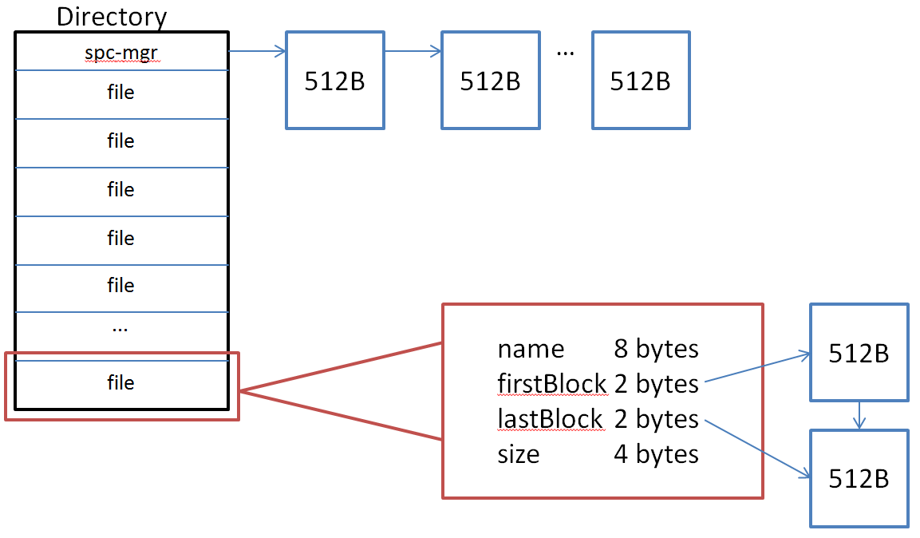

MEASUREMENT DATA

Our system took 14 ms to write and 12 ms to read 10 512 byte blocks, so the read bandwidth is ~ 426,667 bytes/second and the write bandwidth is ~365,714 bytes/second.

Command frame:
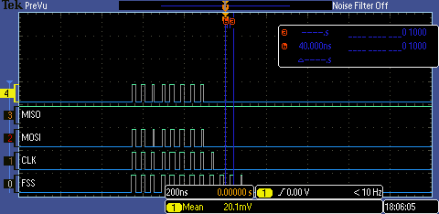
Data frame:
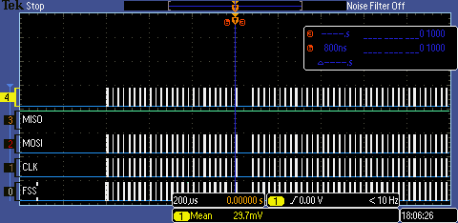
1) Yes. Our implementation has external fragmentation. External fragmentation is when a single file is potentially allocated using non-adjacent sectors in disk. If we create and write 1 byte to 2 files then write 2k bytes to the first file, the first file will allocate sectors 1, 3, 4, 5, and 6. This demonstrates external fragmentation as the file is not allocated using solely adjacent/sequential sectors.
2) Internal fragmentation is the result of a sector being allocated for a file, but the file not using the entirety of that sector. The average number of bytes wasted due to internal fragmentation for a randomly-sized file is 254 bytes. Therefore, the expected wastage for 10 files is 2,540 bytes.
3) Roughly the same as the read/write latency is the biggest issue, and we are not writing large enough blocks of data at a time to result in a noticeable bandwidth change.
4) We can store 31 files in our disk (the free space manager is treated as a hidden file). We can increase this limit by having an expandable directory. The last “file” in the directory could indicate where the next sector of the directory is located, and we could load that sector to continue reading the directory.
5) Yes, we do. If a file is open, any thread can write to it. The write function itself does not place a semaphore on the writing, so therefore the functions writing data must use semaphores to handle the write synchronization. This is because the write function only writes 1 byte. We believed that we would often require writing more than one byte at a time to the file, so we wished to place the semaphores around the redirected printf function to ensure that the data we wished to write was written correctly.

